CpE 111 Homework Assignment #3 Maximum – 100pts

HW#3 is due at the beginning of class on Feb 22, 2006. You must always show or explain your work in a neat and orderly format. You are encouraged to discuss ideas with other students and consult references but your work must be your own.

1. From Givone text (pp119), solve 3.7

2. From Givone text (pp119), solve 3.8.

3. From Givone text (pp120), solve 3.14. (Hint: refer to Example 3.10 in pp. 87)

4. From Givone text (pp120), solve 3.15. (Hint: refer to Example 3.11 in pp. 88)

5. Design an AND-OR PLA (Programmable Logic Array) that implements the functions

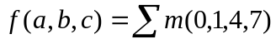
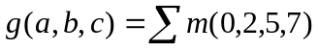

using minimum number of AND and OR gates.

6. Design an OR-AND PLA for the functions

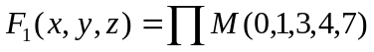
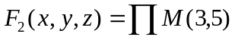
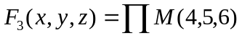
using minimum number of OR and AND gates.

7. Find BCD code words for the following decimal numbers.

(a) 435
(b) 13
(c) 2029

8. For the BCD-to-7-segment decoder, find the minimum SOP and minimum POS forms of the functions a and b using K-maps. (15pts)

9. Using K-maps, determine the minimum SOP and minimum POS forms for each of the following Boolean functions. (15pts)

a. From Givone text (pp 223), 4.7 (a).
b. From Givone text (pp 223), 4.8 (d).

